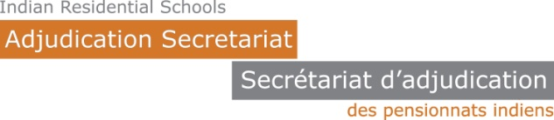

**Indian Residential Schools Independent Assessment Process**

**Request for Review**

**1. Review requestor**

Name of requestor: ____________________________________________

Role: 🞏 Claimant’s counsel 🞏 Government

🞏 Other (specify) ____________________________

Address: ____________________________________________

____________________________________________

Phone: ____________________________________________

Fax: ____________________________________________

Email: ____________________________________________

**2. Decision under review**

I hereby request that the Chief Adjudicator (or designate) review the following decision:

🞏 Original decision 🞏 Review decision

File number: ____________________________________________

Claimant’s name: ____________________________________________

**3. Grounds for review**

I request that the reviewing adjudicator:

🞏 determine whether the adjudicator’s, or reviewing adjudicator’s decision properly applied the IAP model to the facts as found by the adjudicator [Schedule D, III(l)(i)]

OR

🞏 determine whether the adjudicator’s decision contains a palpable and overriding error [Schedule D, III(l)(ii)]

**4. Reason for review:**

Please attach a short written or typed statement of your objections to the decision, not to exceed 1500 words.

**5. Signature:**

_____________________________________  
Signature of requestor or lawyer for requestor

_____________________________________  
[type or print name]

**Please send this completed form to the Secretariat via Electronic Document Interchange (EDI)**

**or**, by mail to:

Office of the Chief Adjudicator  
Indian Residential Schools Adjudication Secretariat  
100 – 1975 Scarth Street  
Regina, Saskatchewan S4P 2H1

The Secretariat will provide your Request for Review to the other parties, who will then have 30 days to send in a reply.